**Install Terraform**

1. Go to official site of Terraform by HashiCorp and install for Windows AMD64

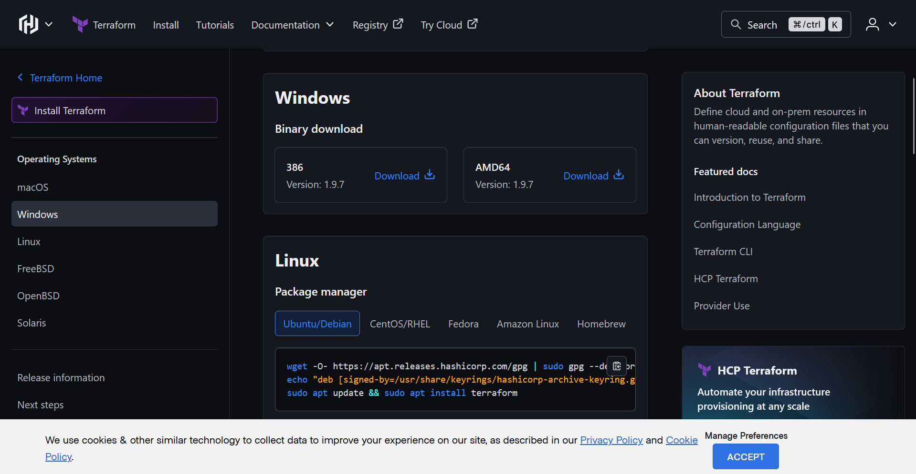

1. After the zip is downloaded, extract and save the folder in location of your choice
2. Copy the path of terraform.exe and add it to path environment variable

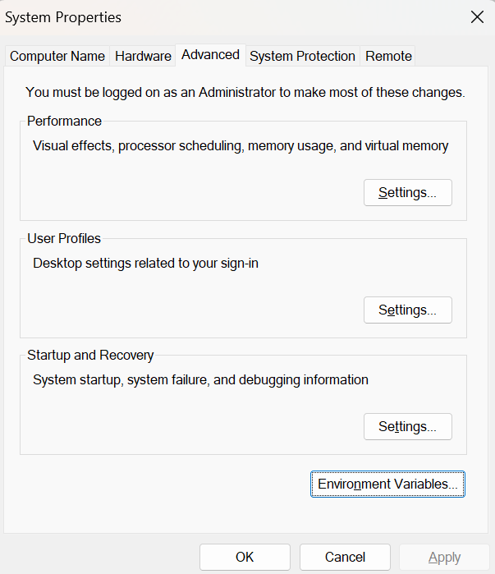

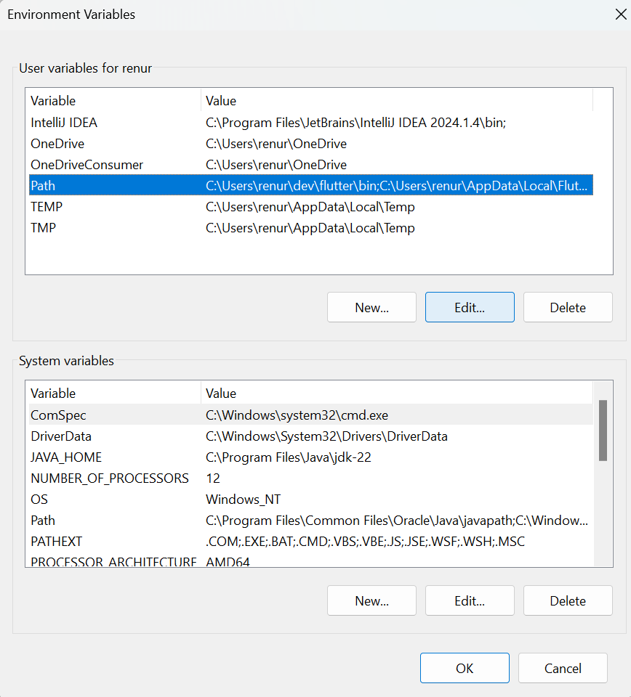

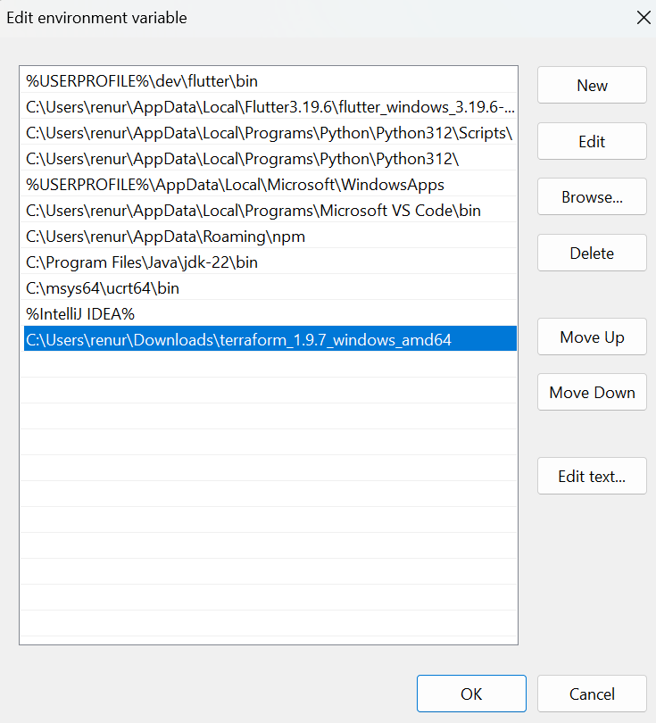

1. Check if terraform is installed

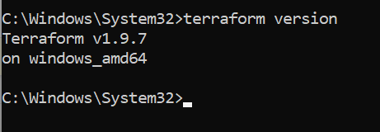

1. Start minikube

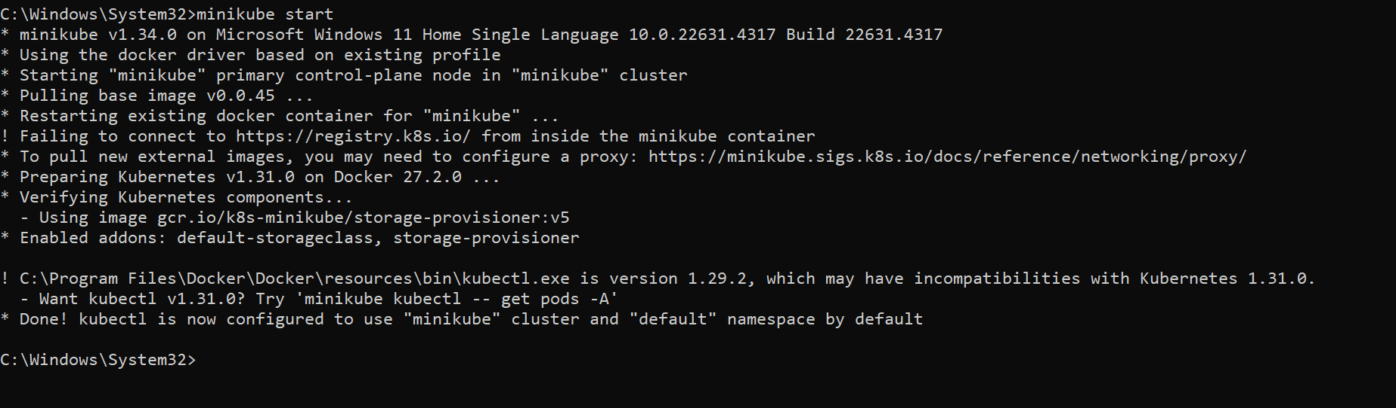

1. Create a folder in Downloads folder called TerraformProject. Create a main.tf file inside it. Copy paste this content inside it:

terraform {

required_providers {

kubernetes = {

source = "hashicorp/kubernetes"

version = "~> 2.0"

}

}

}

provider "kubernetes" {

config_path = "~/.kube/config" # Path to your kubeconfig file (default location)

}

# Basic NGINX Deployment

resource "kubernetes_deployment" "nginx" {

metadata {

name = "nginx-deployment"

}

spec {

replicas = 1 # Deploy 1 replica for simplicity

selector {

match_labels = {

app = "nginx"

}

}

template {

metadata {

labels = {

app = "nginx"

}

}

spec {

container {

name = "nginx"

image = "nginx:latest"

port {

container_port = 80

}

}

}

}

}

}

# Basic Kubernetes Service to Expose NGINX Deployment

resource "kubernetes_service" "nginx" {

metadata {

name = "nginx-service"

}

spec {

selector = {

app = "nginx"

}

port {

port = 80

target_port = 80

}

type = "NodePort" # Simpler than LoadBalancer, exposes a port on each node

}

}

1. Initialize terraform: terraform init

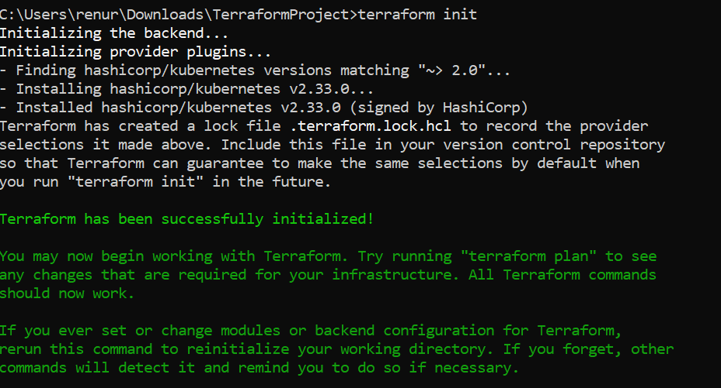

1. Apply the terraform file: terraform apply

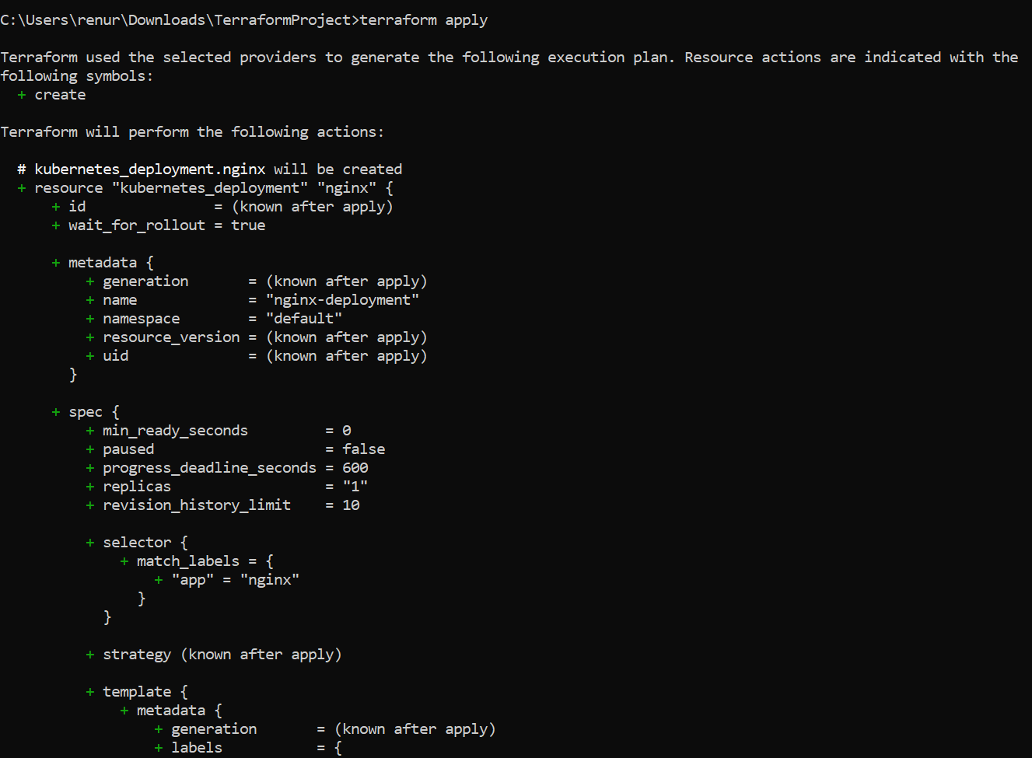

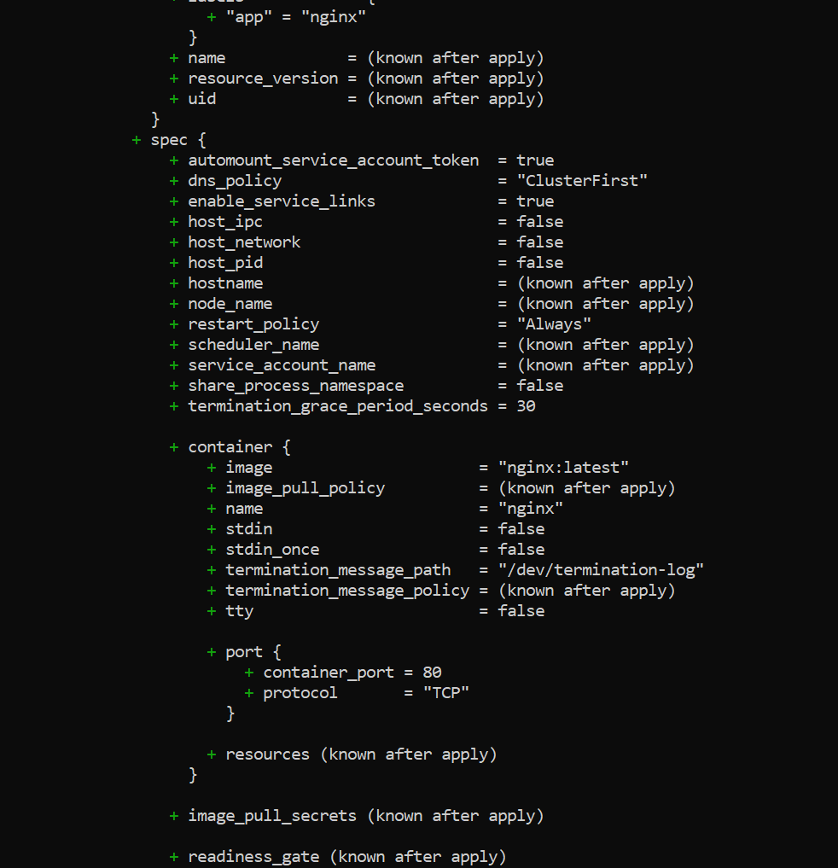

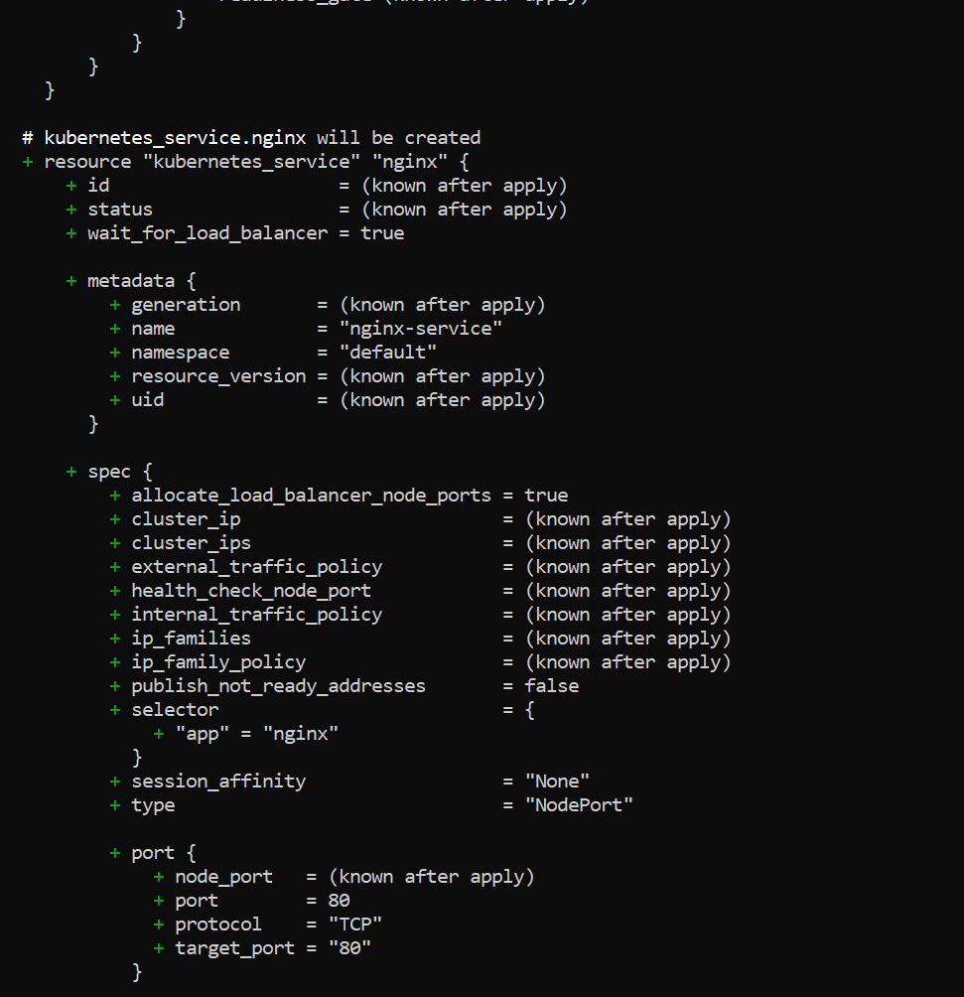

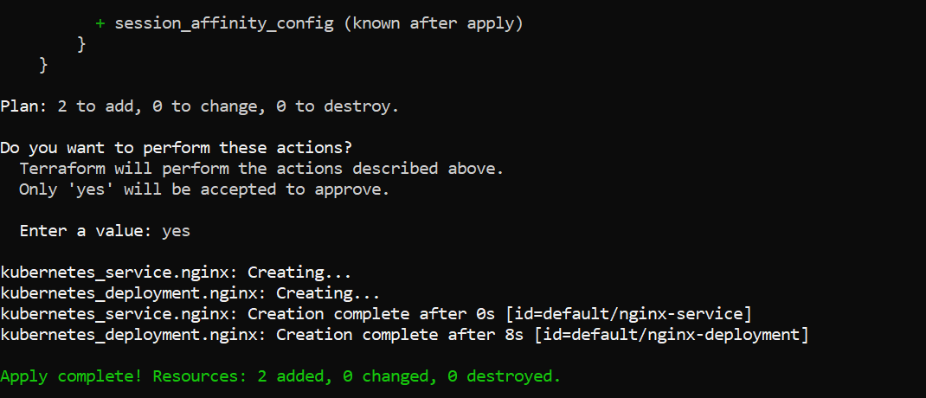

1. Once apply process is over, to access nginx we ca use: minikube service nginx-service

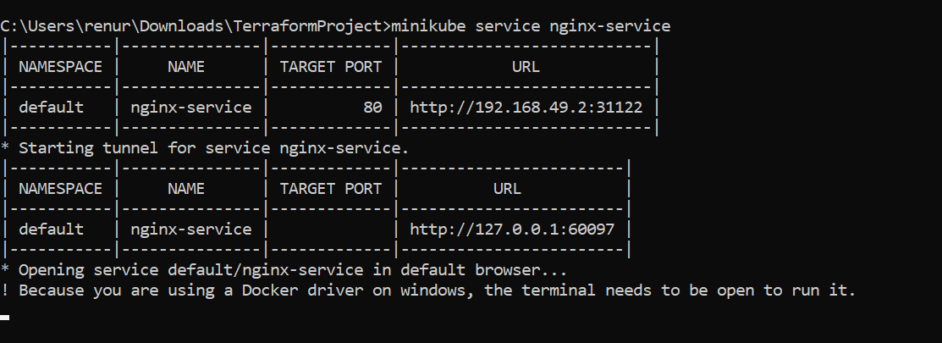

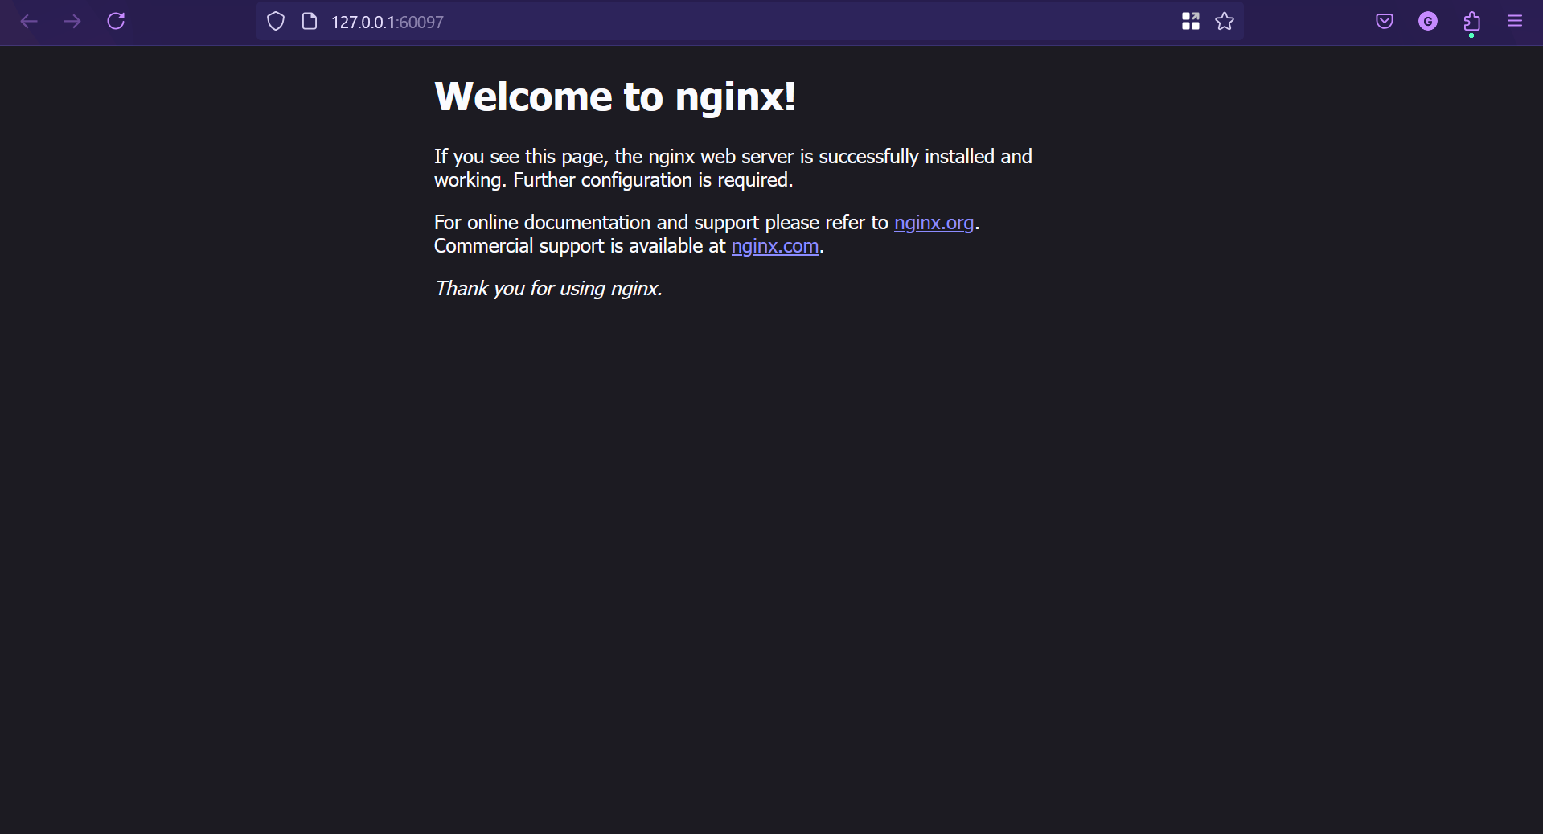

**Terraform with Docker running nginx**

Check if terraform is installed: terraform version

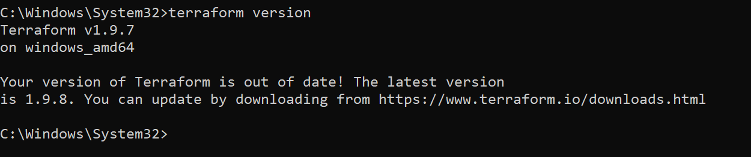

Then start minikube: minikube start

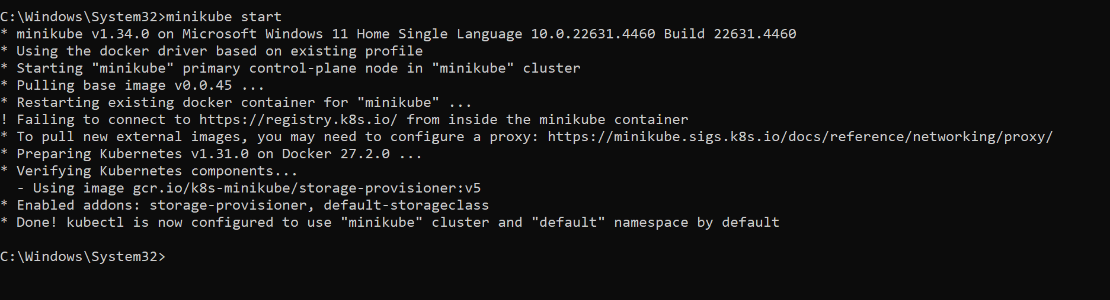

Create a main.tf file

# Specify the Terraform version

terraform {

required_providers {

docker = {

source = "kreuzwerker/docker"

version = "~> 3.0"

}

}

required_version = ">= 1.3.0"

}

# Configure the Docker provider

provider "docker" {

host = "npipe:////.//pipe//docker_engine" # For Windows

# host = "unix:///var/run/docker.sock" # For Linux/Mac

}

# Pull the Nginx Docker image

resource "docker_image" "nginx" {

name = "nginx:latest"

keep_locally = false

}

# Create the Nginx container

resource "docker_container" "nginx" {

image = docker_image.nginx.name

name = "nginx-container"

ports {

internal = 80

external = 8080

}

}

Navigate to the folder where main.tf is located and run terraform init

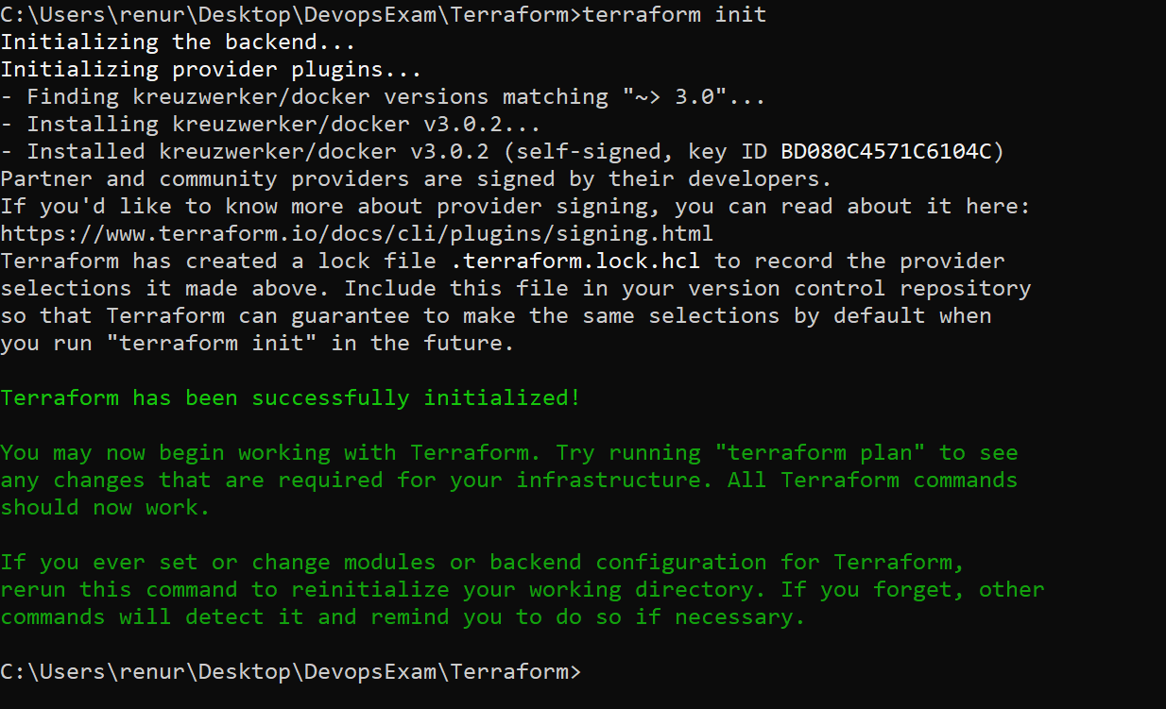

Apply the main.tf file: terraform apply

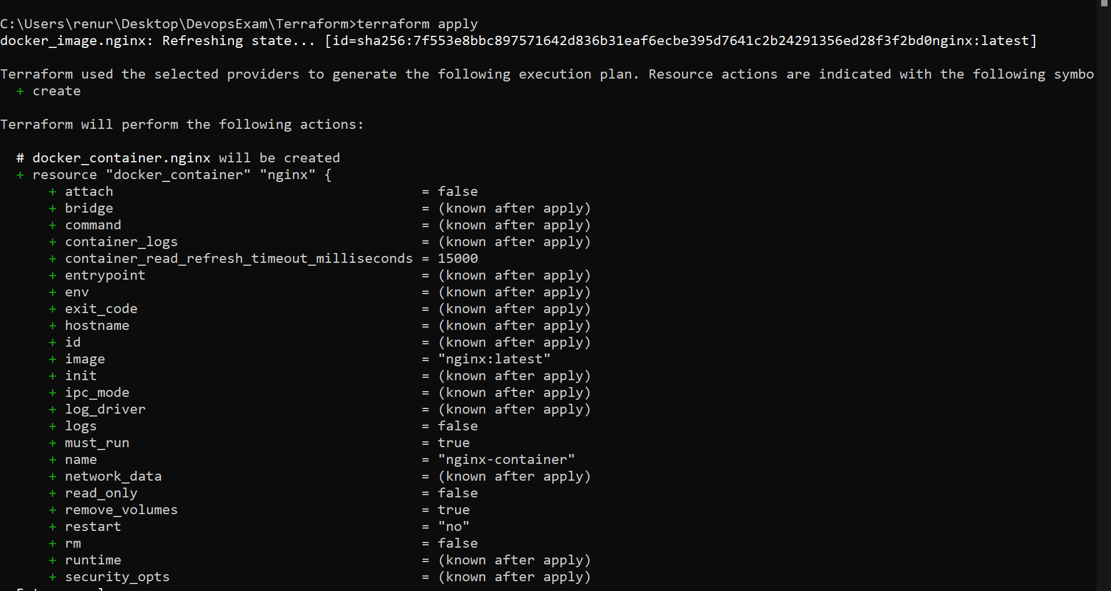

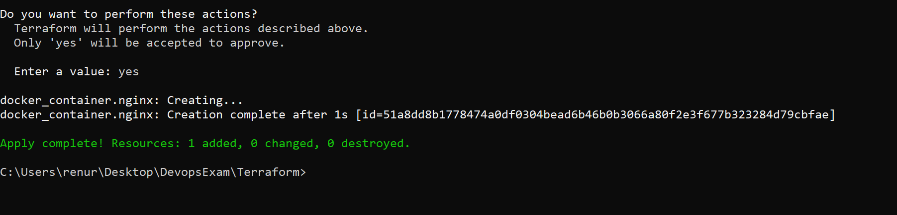

Now check in docker desktop the container of nginx will be running

